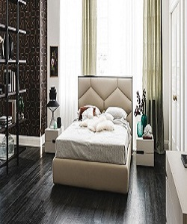

Bed

$359.47

Availability: In stock

Description

The ultra-modern Bed will transform an ordinary bedroom into the center of attention. With its curvaceous contours and spacious sleeping surface, the Bed evokes a tranquil oasis of calm and relaxation. The nature and design of this bed allows it to suit most modern bedrooms.